Code refactoring and structure improvement
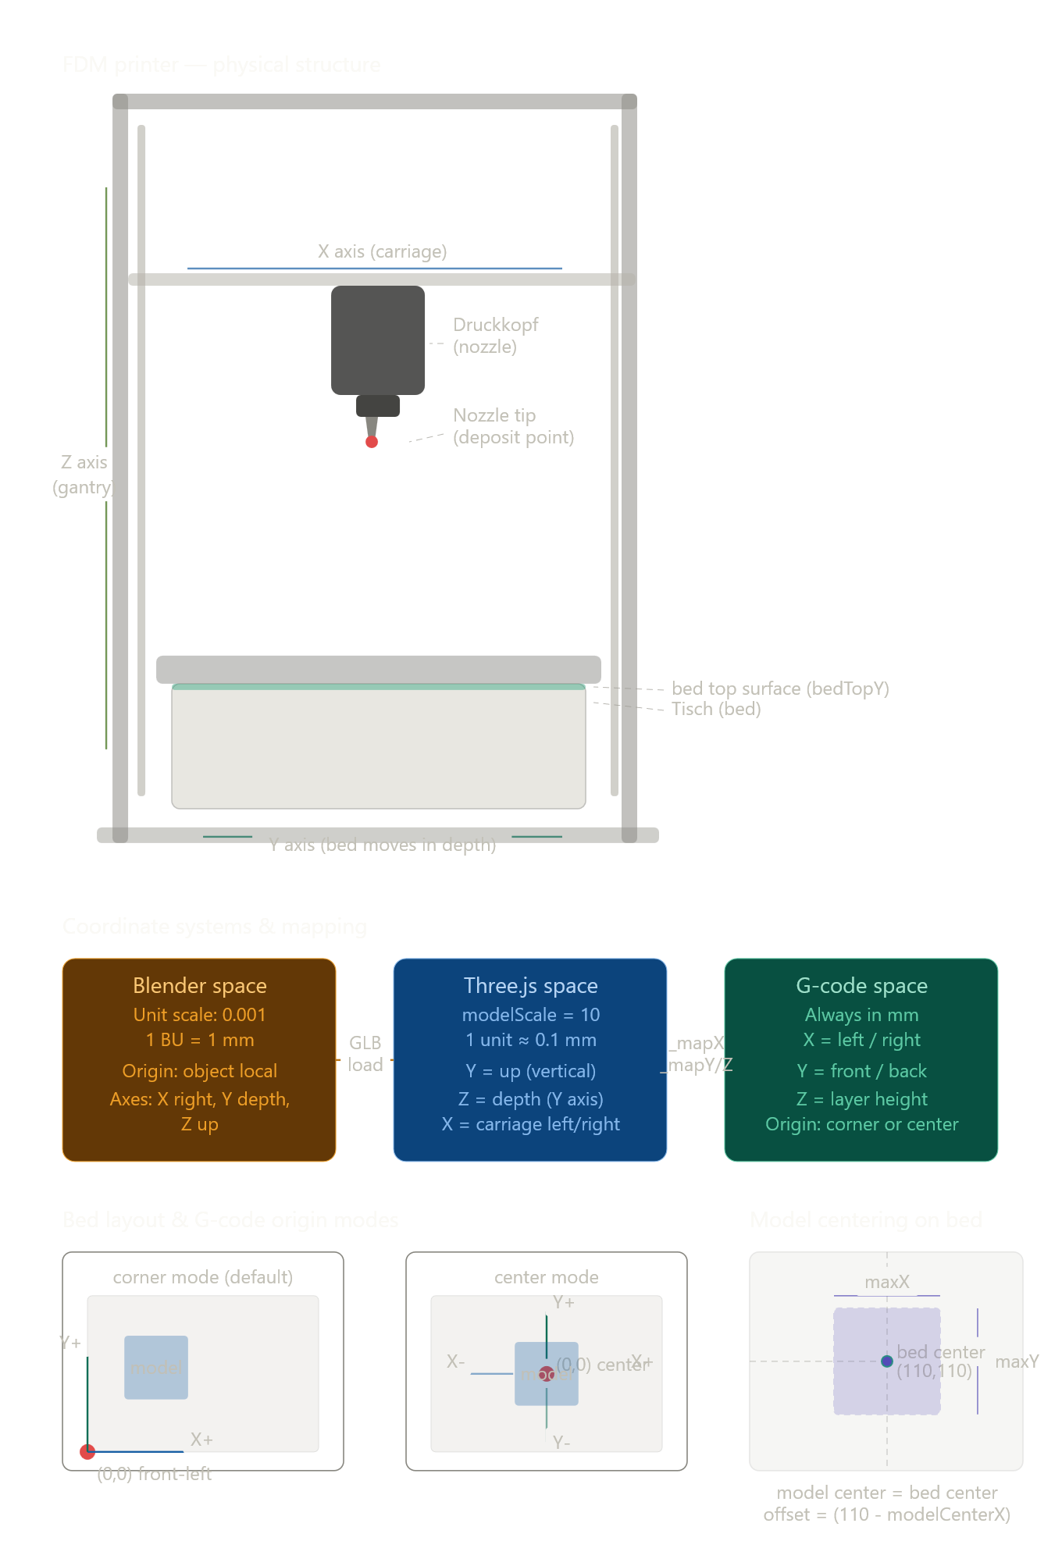
Here is what both documents are telling us, synthesized into one clear picture.
The three coordinate worlds and why they clash
The simulation lives in three separate spaces that all use different rules. Blender built the model in millimeters with a unit scale of 0.001, so 1 Blender unit equals 1 mm. Three.js has no fixed units — the project applies modelScale = 10, which means 1 Three.js unit becomes roughly 0.1 mm. G-code is always in real millimeters and has no concept of any of this scaling. Every bug we have been chasing comes from the friction between these three worlds.
The Tisch / Druckkopf misalignment problem
The Positions document identifies the key physical fact: neither the bed (Tisch) nor the nozzle (Druckkopf) sit at the Three.js world origin. The bed is almost centered on the Y axis but not on X. The nozzle is off-center in both X and Y. This is why the _worldToTischLocal() matrix inversion approach kept drifting — we were converting nozzle world position into a local space whose origin was itself not where we assumed it to be.
Why the filament was always wrong
The Printing Issues document and the screenshots together confirm the sequence of failures. The filament was parented to Tisch and stored in Tisch local space, but Tisch moves as the Y axis animates. Every stored historical point gets dragged along with the bed, turning correct-looking deposits into spaghetti. The fix confirmed in the last session — parent to scene, store in world space — is the right one.
The corner vs center origin problem
G-code files from slicers almost always use the front-left corner as (0,0). The simulation was defaulting to corner mode but the placement offset was not being applied consistently through the chain: _mapX/_mapY in PrintingMotion had the offset logic but the FilamentRenderer was not receiving or using it. This is why a centered tower appeared shifted to the corner of the bed.
What a correctly centered print needs
From the document: get the model's bounding box, find its center (maxX/2, maxY/2), offset the G-code origin so that center lands on (110, 110) — the bed center for a 220×220 mm bed. The simulation needs a printer profile concept that stores the actual bed dimensions (220×220×250 for the Ender-3 default), the origin mode, and the offset calculation, rather than scattering those values across multiple files.

